RECERTIFYING AS AN OFFICIAL

- On the State Association home screen, click on Member Sign In.
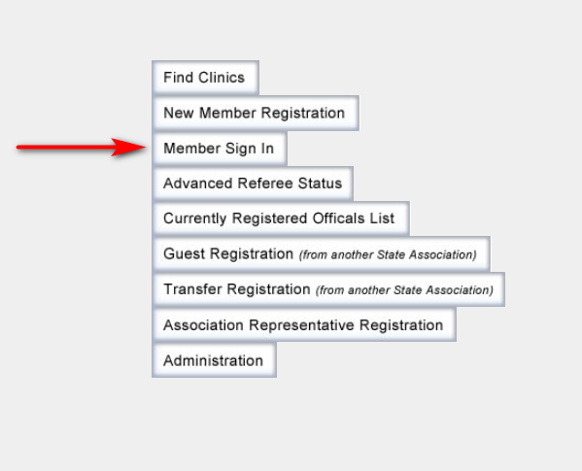

- Enter correct Username and Password. Select the Login button. If you do not remember your Login ID or Password, simply click one of the Forgot links below the login information for assistance.
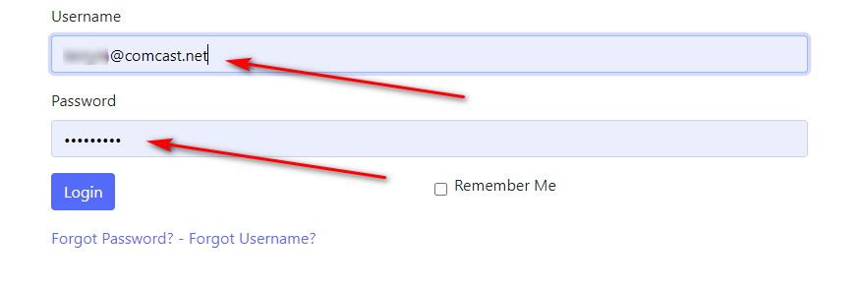
- On your Home page, select Register for Clinic/Fitness Test under the Registration drop down menu.
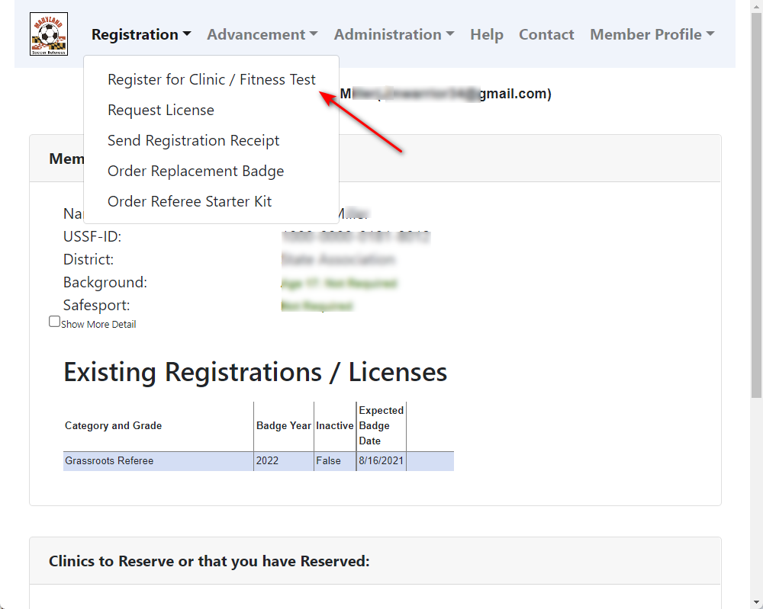
- Step 1 of 3: Create Registration.
  - Answer the Legal Question and select the appropriate type(s) of registration.
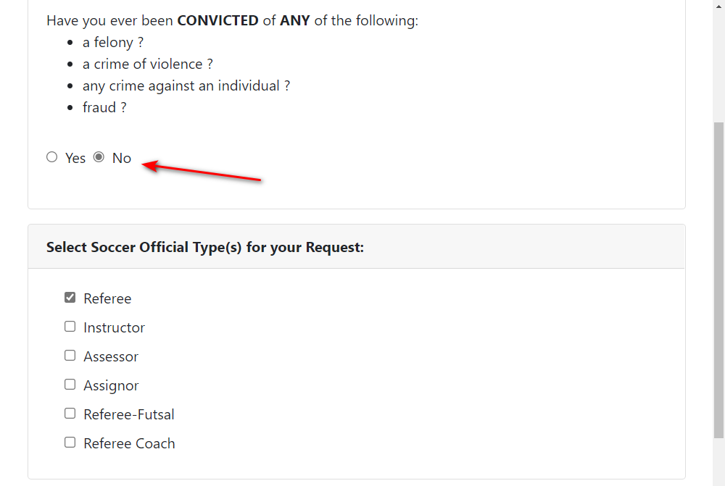
  - Scroll down and select the Registration Type for each. NOTE: If you are upgrading, the appropriate Upgrade box must be checked at this point.
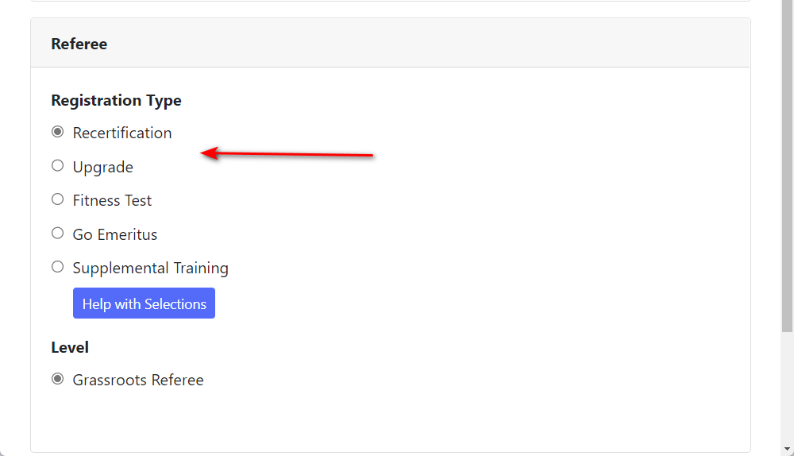
  - Scroll down and select Submit Request.
- Step 2 of 3: Reserve the Clinic. Find the correct clinic you are registering for. If you wish to search a specific location, you may select that option from the Clinic Location drop down menu. Select the Reserve Clinic button and then Submit.
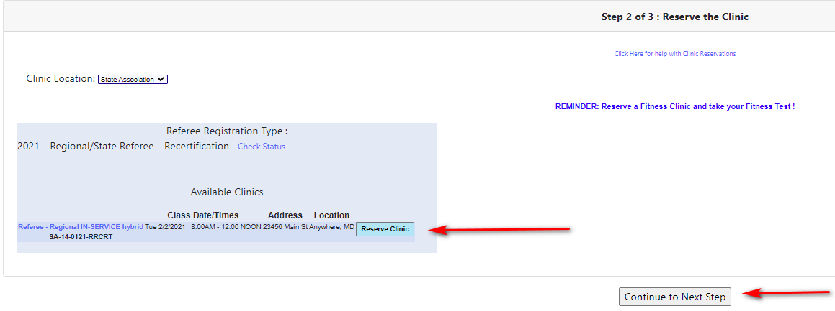

- Step 3 of 3: Checkout to pay Associated Fees. This step will display your registration and clinic fees due. When the total is confirmed, press the Complete Requests and Pay Fees button. NOTE: All items highlighted green must be paid.
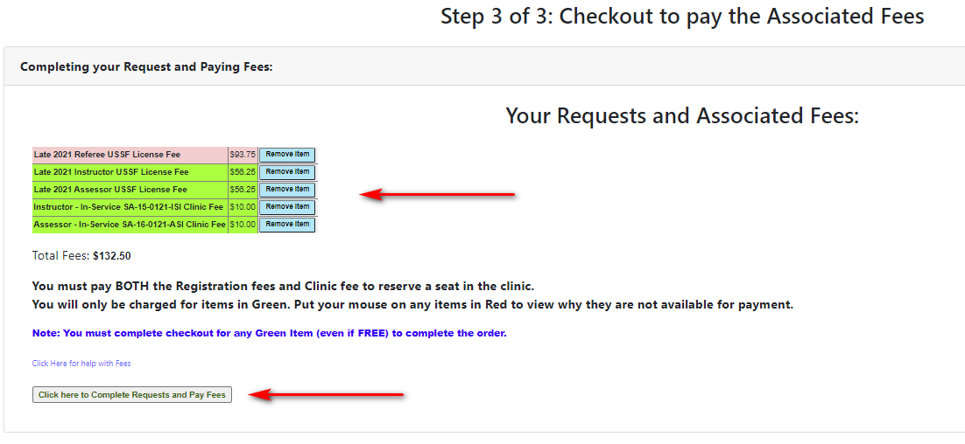

- The final screens to appear in this registration process pertain to the payment options. At the bottom in the Billing Information box, you will be asked to select the type of payment option for paying your registration fee. After choosing the Payment Type, select Click Here to Pay.
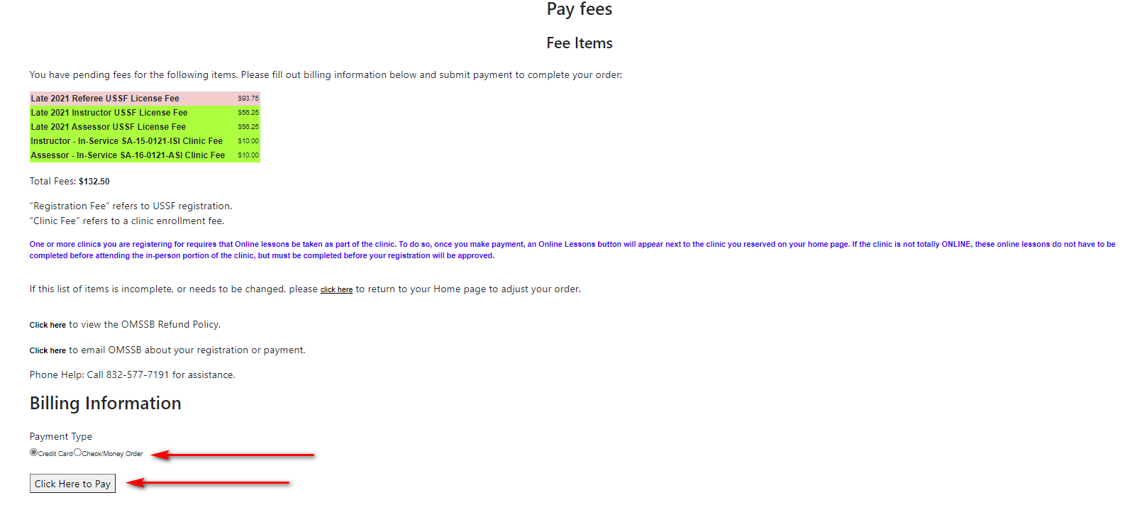
- On the Payment screen – fill in the payment information to proceed with the final charge of your registration process. Your email address should appear above, so that once payment has been submitted, you will be emailed a receipt for your records.
