©20 22 U . S . S oc c e r | CO NF I D E NTI A L — Not to be s h ar e d w i th ou t U .S . S oc c e r appr ov a l
2024 ELIGIBILITY & REQUIREMENTS
U.S. SOCCER REFEREE PROGRAM
1

IMPORTANT REMINDER

The following information is a general outline of the eligibility and certification / re-certification requirements.
For details on current requirements for each course, please see the Course Timeline in the Learning Center PRIOR to enrolling.

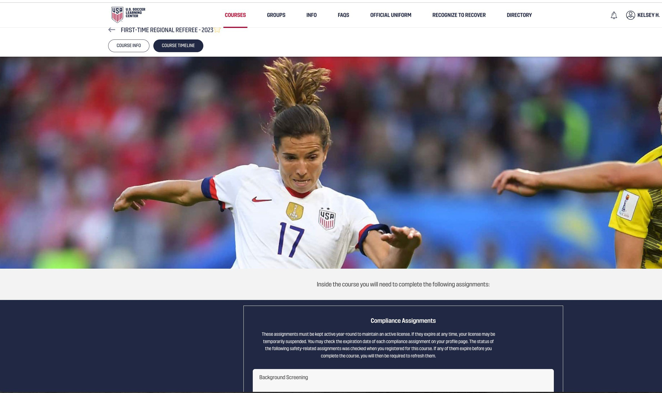
2

©20 22 U . S . S oc c e r | CO NF I D E NTI A L — Not to be s h ar e d w i th ou t U .S . S oc c e r appr ov a l
2024 REFEREE PATHWAY
ELIGIBILITY & GENERAL REQUIREMENTS
3

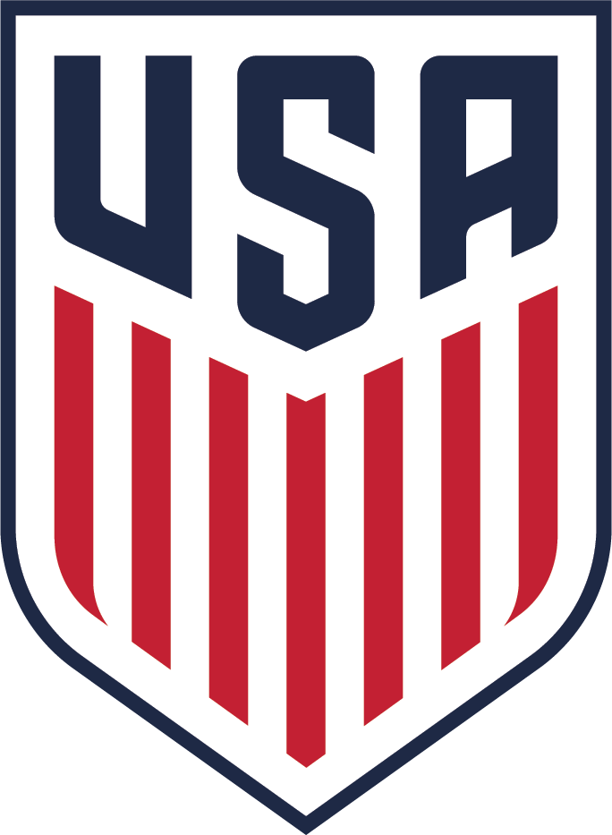
FIRST-TIME REFEREE*
©20 22 U . S . S oc c e r | CO NF I D E NTI A L — Not to be s h ar e d w i th ou t U .S . S oc c e r appr ov a l
2024 LICENSE REQUIREMENTS

FIRST-TIME REFEREE REQUIREMENTS
AGE | 13 YEARS OF AGE OR OLDER
ENROLLMENT | REGISTRATION
PREVIOUS CERTIFICATION EXPERIENCE | N/A
SAFETY & COMPLIANCE | BACKGROUND SCREENING (18 yrs. and older) SAFESPORT TRAINED (18 yrs. and older)  SAFE AND HEALTHY PLAYING ENVIRONMENTS
TRAINING  (online and/or in-person) | ONLINE REFEREE COURSE  IN-PERSON or VIRTUAL FIELD TRAINING
FITNESS TEST | N/A
PRACTICAL ASSIGNMENTS | N/A

REFEREE

*previously Grassroots Referee

REFEREE* RECERTIFICATION
©20 22 U . S . S oc c e r | CO NF I D E NTI A L — Not to be s h ar e d w i th ou t U .S . S oc c e r appr ov a l
2024 LICENSE REQUIREMENTS

REFEREE RE-RECERTIFICATION REQUIREMENTS
AGE | 13 YEARS OF AGE OR OLDER
ENROLLMENT | REGISTRATION
PREVIOUS CERTIFICATION EXPERIENCE | MUST HAVE HELD AT LEAST ONE (1) REFEREE* LICENSE DURING THE PREVIOUS THREE (3 ) REGISTRATION YEARS OR  HELD A REGIONAL REFEREE LICENSE IN THE PREVOUS REGISTRATION YEAR
SAFETY & COMPLIANCE | BACKGROUND SCREENING (18 yrs. and older) SAFESPORT TRAINED (18 yrs. and older) SAFE AND HEALTHY PLAYING ENVIRONMENTS
TRAINING  (online) | ONLINE REFEREE RECERTIFICATION COURSE
FITNESS TEST | N/A
PRACTICAL ASSIGNMENTS | N/A

REFEREE

*previously Grassroots Referee

FIRST-TIME REGIONAL REFEREE 2024 LICENSE REQUIREMENTS
REGIONAL REFEREE
©20 22 U . S . S oc c e r | CO NF I D E NTI A L — Not to be s h ar e d w i th ou t U .S . S oc c e r appr ov a l

FIRST-TIME REGIONAL REFEREE REQUIREMENTS
AGE | 18 YEARS OF AGE OR OLDER
ENROLLMENT | REGISTRATION
PREVIOUS CERTIFICATION EXPERIENCE | MUST HAVE HELD A REFEREE LICENSE* FOR EACH OF THE TWO (2) PREVIOUS REGISTRATION YEARS  OR  MUST MEET THE ACCELERATED PATHWAY ELIGIBILITY OPTION**
PREVIOUS GAME EXPERIENCE | 25 GAMES AS A REFEREE AND 15 GAMES AS AN ASSISTANT REFEREE AT THE ADULT AMATEUR LEVEL
SAFETY & COMPLIANCE | BACKGROUND SCREENING SAFESPORT TRAINED  SAFE AND HEALTHY PLAYING ENVIRONMENTS
TRAINING  (online and/or in-person) | REGIONAL REFEREE ONLINE COURSE IN-PERSON FIELD TRAINING
FITNESS TEST | SPRINT / INTERVAL TESTS (FIFA WOMEN'S REFEREE TEST)  Male – Category 1 Female – Category 3
PRACTICAL ASSIGNMENTS | MINIMUM OF THREE (3) PASSING EVALUATIONS WITHIN THE PAST 12 MONTHS: TWO (2) AT THE ADULT AMATEUR LEVEL,  ONE (1) AT THE HIGHEST YOUTH LEVEL (U18 OR U19) (2 X 45-minute half)  CHECK WITH YOUR STATE REFEREE COMMITTEE FOR INFORMATION ON WHO IS ELIGIBLE TO CONDUCT THESE EVALUATIONS
*previously Grassroots Referee
REFEREE
** see 2024 Accelerated Pathways for High Level Officials, Coaches, and Players for additional information

REGIONAL REFEREE RE-CERTIFICATION 2024 LICENSE REQUIREMENTS
REFEREE
REGIONAL REFEREE
©20 22 U . S . S oc c e r | CO NF I D E NTI A L — Not to be s h ar e d w i th ou t U .S . S oc c e r appr ov a l

REGIONAL REFEREE RE-CERTIFICATION REQUIREMENTS
AGE | 18 YEARS OF AGE OR OLDER
ENROLLMENT | REGISTRATION
PREVIOUS CERTIFICATION EXPERIENCE | MUST HAVE HELD AT LEAST ONE (1) REGIONAL LICENSE IN THE PREVIOUS THREE (3) REGISTRATION YEARS  OR  MUST HAVE HELD A NATIONAL REFEREE OR NATIONAL ASSISTANT REFEREE LICENSE DURING THEIR REFEREE CAREER
SAFETY & COMPLIANCE | BACKGROUND SCREENING SAFESPORT TRAINED  SAFE AND HEALTHY PLAYING ENVIRONMENTS
TRAINING  (online and/or in-person) | REGIONAL REFEREE RECERTIFYING ONLINE COURSE
FITNESS TEST | SPRINT / INTERVAL TESTS (FIFA WOMEN'S REFEREE TEST)  Male – Category 1 Female – Category 3
PRACTICAL ASSIGNMENTS | MINIMUM OF TWO (2) PASSING EVALUATIONS WITHIN THE PAST 12 MONTHS: ONE (1) AT THE ADULT AMATEUR LEVEL,  ONE (1) AT THE HIGHEST YOUTH LEVEL (U18 OR U19) (2 X 45-minute half)  CHECK WITH YOUR STATE REFEREE COMMITTEE FOR INFORMATION ON WHO IS ELIGIBLE TO CONDUCT THESE EVALUATIONS

REGIONAL EMERITUS REFEREE 2024 LICENSE REQUIREMENTS
REFEREE
EMERITUS
©20 22 U . S . S oc c e r | CO NF I D E NTI A L — Not to be s h ar e d w i th ou t U .S . S oc c e r appr ov a l

REGIONAL EMERITUS REFEREE CERTIFICATION AND RE-CERTIFICATION REQUIREMENTS
AGE | 45 YEARS OF AGE OR OLDER
ENROLLMENT | REGISTRATION
PREVIOUS CERTIFICATION EXPERIENCE | MUST HAVE HELD AT LEAST THREE (3) REGIONAL REFEREE OR REGIONAL EMERITUS LICENSES IN THEIR CAREER
SAFETY & COMPLIANCE | BACKGROUND SCREENING SAFESPORT TRAINED  SAFE AND HEALTHY PLAYING ENVIRONMENTS
TRAINING  (online and/or in-person) | EMERITUS ONLINE COURSE
FITNESS TEST | N/A
PRACTICAL ASSIGNMENTS | N/A

NATIONAL EMERITUS REFEREE 2024 LICENSE REQUIREMENTS
REFEREE
EMERITUS
©20 22 U . S . S oc c e r | CO NF I D E NTI A L — Not to be s h ar e d w i th ou t U .S . S oc c e r appr ov a l

NATIONAL EMERITUS REFEREE CERTIFICATION AND RE-CERTIFICATION REQUIREMENTS
AGE | 45 YEARS OF AGE OR OLDER
ENROLLMENT | REGISTRATION
PREVIOUS CERTIFICATION EXPERIENCE | MUST HAVE HELD AT LEAST THREE (3) NATIONAL REFEREE, NATIONAL ASSISTANT REFEREE, PRO, FIFA  OR  NATIONAL EMERITUS LICENSES IN THEIR CAREER
SAFETY & COMPLIANCE | BACKGROUND SCREENING SAFESPORT TRAINED  SAFE AND HEALTHY PLAYING ENVIRONMENTS
TRAINING  (online and/or in-person) | EMERITUS ONLINE COURSE
FITNESS TEST | N/A
PRACTICAL ASSIGNMENTS | N/A

FIRST-TIME NATIONAL REFEREE / ASSISTANT REFEREE 2024 LICENSE REQUIREMENTS
REFEREE
REGIONAL
NATIONAL
©20 22 U . S . S oc c e r | CO NF I D E NTI A L — Not to be s h ar e d w i th ou t U .S . S oc c e r appr ov a l

FIRST-TIME NATIONAL REFEREE / ASSISTANT REFEREE REQUIREMENTS
AGE | 21 YEARS OF AGE OR OLDER
ENROLLMENT | APPLICATION REQUIRED  SELECTED BY U.S. SOCCER NATIONAL SELECTION COMMITTEE
PREVIOUS CERTIFICATION EXPERIENCE | MUST HAVE HELD A REGIONAL REFEREE LICENSE FOR EACH OF THE TWO (2) PREVIOUS REGISTRATION YEARS
PREVIOUS GAME EXPERIENCE | 65 GAMES AT THE ADULT AMATURE LEVEL:  40 GAMES AS A REFEREE  25 GAMES AS AN ASSISTANT REFEREE
SAFETY & COMPLIANCE | NCSI BACKGROUND SCREENING SAFESPORT TRAINED  SAFE AND HEALTHY PLAYING ENVIRONMENTS
TRAINING  (online and/or in-person) | ONLINE NATIONAL MATCH OFFICIAL COURSE  ATTEND AND SUCCESSFULLY COMPLETE IN-PERSON NATIONAL CAMP
FITNESS TEST | FIFA FITNESS TEST  (REFEREE or ASSISTANT REFEREE and GENDER SPECIFIC) CATEGORY 1
PRACTICAL ASSIGNMENTS | MINIMUM OF THREE (3) PASSING NATIONAL EVALUATIONS AS EITHER REFEREE OR ASSISTANT REFEREE  EVALUATIONS MUST BE COMPLETED BY THREE (3) DIFFERENT NATIONAL REFEREE COACHES WITHIN THE PREVIOUS REGISTRATION YEAR

NATIONAL REFEREE / ASSISTANT REFEREE RE-CERTIFICATION
REFEREE
REGIONAL
NATIONAL
©20 22 U . S . S oc c e r | CO NF I D E NTI A L — Not to be s h ar e d w i th ou t U .S . S oc c e r appr ov a l
2024 LICENSE REQUIREMENTS

NATIONAL RE-CERTIFICATION REQUIREMENTS
AGE | 21 YEARS OF AGE OR OLDER
ENROLLMENT | APPLICATION REQUIRED  SELECTED BY U.S. SOCCER NATIONAL SELECTION COMMITTEE
PREVIOUS CERTIFICATION EXPERIENCE | MUST HAVE HELD ONE (1) NATIONAL MATCH OFFICIAL LICENSE OR HIGHER IN THE PREVIOUS REGISTRATION YEAR
PREVIOUS GAME EXPERIENCE | 12 GAMES IN SELECTED TRACK AT THE AMATEUR ADULT OR HIGHER LEVEL (PROFESSIONAL or INTERNATIONAL)
SAFETY & COMPLIANCE | NCSI BACKGROUND SCREENING SAFESPORT TRAINED  SAFE AND HEALTHY PLAYING ENVIRONMENTS
TRAINING  (online and/or in-person) | ONLINE NATIONAL MATCH OFFICIAL RECERTIFICATION COURSE ATTEND AND SUCCESSFULLY COMPLETE IN-PERSON NATIONAL CAMP
FITNESS TEST | FIFA FITNESS TEST  (REFEREE or ASSISTANT REFEREE and GENDER SPECIFIC) CATEGORY 1
PRACTICAL ASSIGNMENTS | MINIMUM OF THREE (3) PASSING NATIONAL EVALUATIONS WITHIN SELECTED TRACK  EVALUATIONS MUST BE COMPLETED BY THREE (3) DIFFERENT NATIONAL REFEREE COACHES WITHIN THE PREVIOUS REGISTRATION YEAR

FIRST-TIME PRO REFEREE / ASSISTANT REFEREE / VIDEO MATCH OFFICIAL (VMO) 2024 LICENSE REQUIREMENTS
REFEREE
REGIONAL
NATIONAL
PRO
©20 22 U . S . S oc c e r | CO NF I D E NTI A L — Not to be s h ar e d w i th ou t U .S . S oc c e r appr ov a l

FIRST-TIME PRO REFEREE / ASSISTANT REFEREE / VIDEO MATCH OFFICIAL REQUIREMENTS
AGE | 21 YEARS OF AGE OR OLDER
ENROLLMENT | DETERMINED BY PRO
PREVIOUS CERTIFICATION EXPERIENCE | MUST HAVE HELD A NATIONAL MATCH OFFICIAL LICENSE FOR EACH OF THE TWO (2) PREVIOUS REGISTRATION YEARS
SAFETY & COMPLIANCE | NCSI BACKGROUND SCREENING SAFESPORT TRAINED  SAFE AND HEALTHY PLAYING ENVIRONMENTS
TRAINING  (online and/or in-person) | ONLINE PRO COURSE  ATTEND AND SUCCESSFULLY COMPLETE IN PERSON PRO PRESEASON CAMP
FITNESS TEST | FIFA FITNESS TEST  (REFEREE or ASSISTANT REFEREE and GENDER SPECIFIC
PRACTICAL ASSIGNMENTS | PASSING PRO ASSESSMENT CRITERIA (BASED ON PRO/PSRA CBA)

PRO REFEREE / ASSISTANT REFEREE / VIDEO MATCH OFFICIAL (VMO) RE-CERTIFICATION 2024 LICENSE REQUIREMENTS
REFEREE
REGIONAL
NATIONAL
PRO
©20 22 U . S . S oc c e r | CO NF I D E NTI A L — Not to be s h ar e d w i th ou t U .S . S oc c e r appr ov a l

PRO REFEREE / ASSISTANT REFEREE /
VIDEO MATCH OFFICIAL RE-CERTIFICATION REQUIREMENTS
AGE | 21 YEARS OF AGE OR OLDER
ENROLLMENT | DETERMINED BY PRO
PREVIOUS CERTIFICATION EXPERIENCE | MUST HAVE HELD ONE (1) PRO OFFICIAL LICENSE IN THE PREVIOUS REGISTRATION YEAR
PREVIOUS GAME EXPERIENCE | 10 GAMES IN SELECTED TRACK
SAFETY & COMPLIANCE | NCSI BACKGROUND SCREENING SAFESPORT TRAINED  SAFE AND HEALTHY PLAYING ENVIRONMENTS
TRAINING  (online and/or in-person) | ONLINE PRO MATCH OFFICIAL COURSE  ATTEND AND SUCCESSFULLY COMPLETE IN PERSON PRO PRESEASON CAMP
FITNESS TEST | FIFA FITNESS TEST  (REFEREE or ASSISTANT REFEREE and GENDER SPECIFIC)
PRACTICAL ASSIGNMENTS | PASSING PRO ASSESSMENT CRITERIA (BASED ON PRO/PSRA CBA)

FIRST-TIME & RE-CERTIFICATION
REFEREE
REGIONAL
NATIONAL
PRO
FIFA
©20 22 U . S . S oc c e r | CO NF I D E NTI A L — Not to be s h ar e d w i th ou t U .S . S oc c e r appr ov a l
FIFA REFEREE / ASSISTANT REFEREE / VIDEO MATCH OFFICIAL (VMO) 2024 LICENSE REQUIREMENTS

FIRST-TIME FIFA REFEREE / ASSISTANT REFEREE / VIDEO MATCH OFFICIAL REQUIREMENTS
AGE | VARIES BY LICENSE TYPE
ENROLLMENT | RECOMMENDED BY U.S. SOCCER REFEREEE COMMITTEE APPROVED BY USSF BOARD OF DIRECTORS  SELECTED BY FIFA
PREVIOUS CERTIFICATION EXPERIENCE | MUST HAVE HELD A PRO/FIFA MATCH OFFICIAL LICENSE DURING THE PREVIOUS REGISTRATION YEAR
PREVIOUS GAME EXPERIENCE | TWO (2) YEARS WORKING IN THE DIVISION I PROFESSIONAL LEAGUES
SAFETY & COMPLIANCE | NCSI BACKGROUND SCREENING SAFESPORT TRAINED  SAFE AND HEALTHY PLAYING ENVIRONMENTS
TRAINING  (online and/or in-person) | ONLINE FIFA MATCH OFFICIAL COURSE  ATTEND AND SUCCESSFULLY COMPLETE IN-PERSON PRO PRESEASON CAMP
FITNESS TEST | FIFA FITNESS TEST  (REFEREE or ASSISTANT REFEREE and GENDER SPECIFIC
PRACTICAL ASSIGNMENTS | PASSING PRO ASSESSMENT CRITERIA (BASED ON PRO/PSRA CBA)

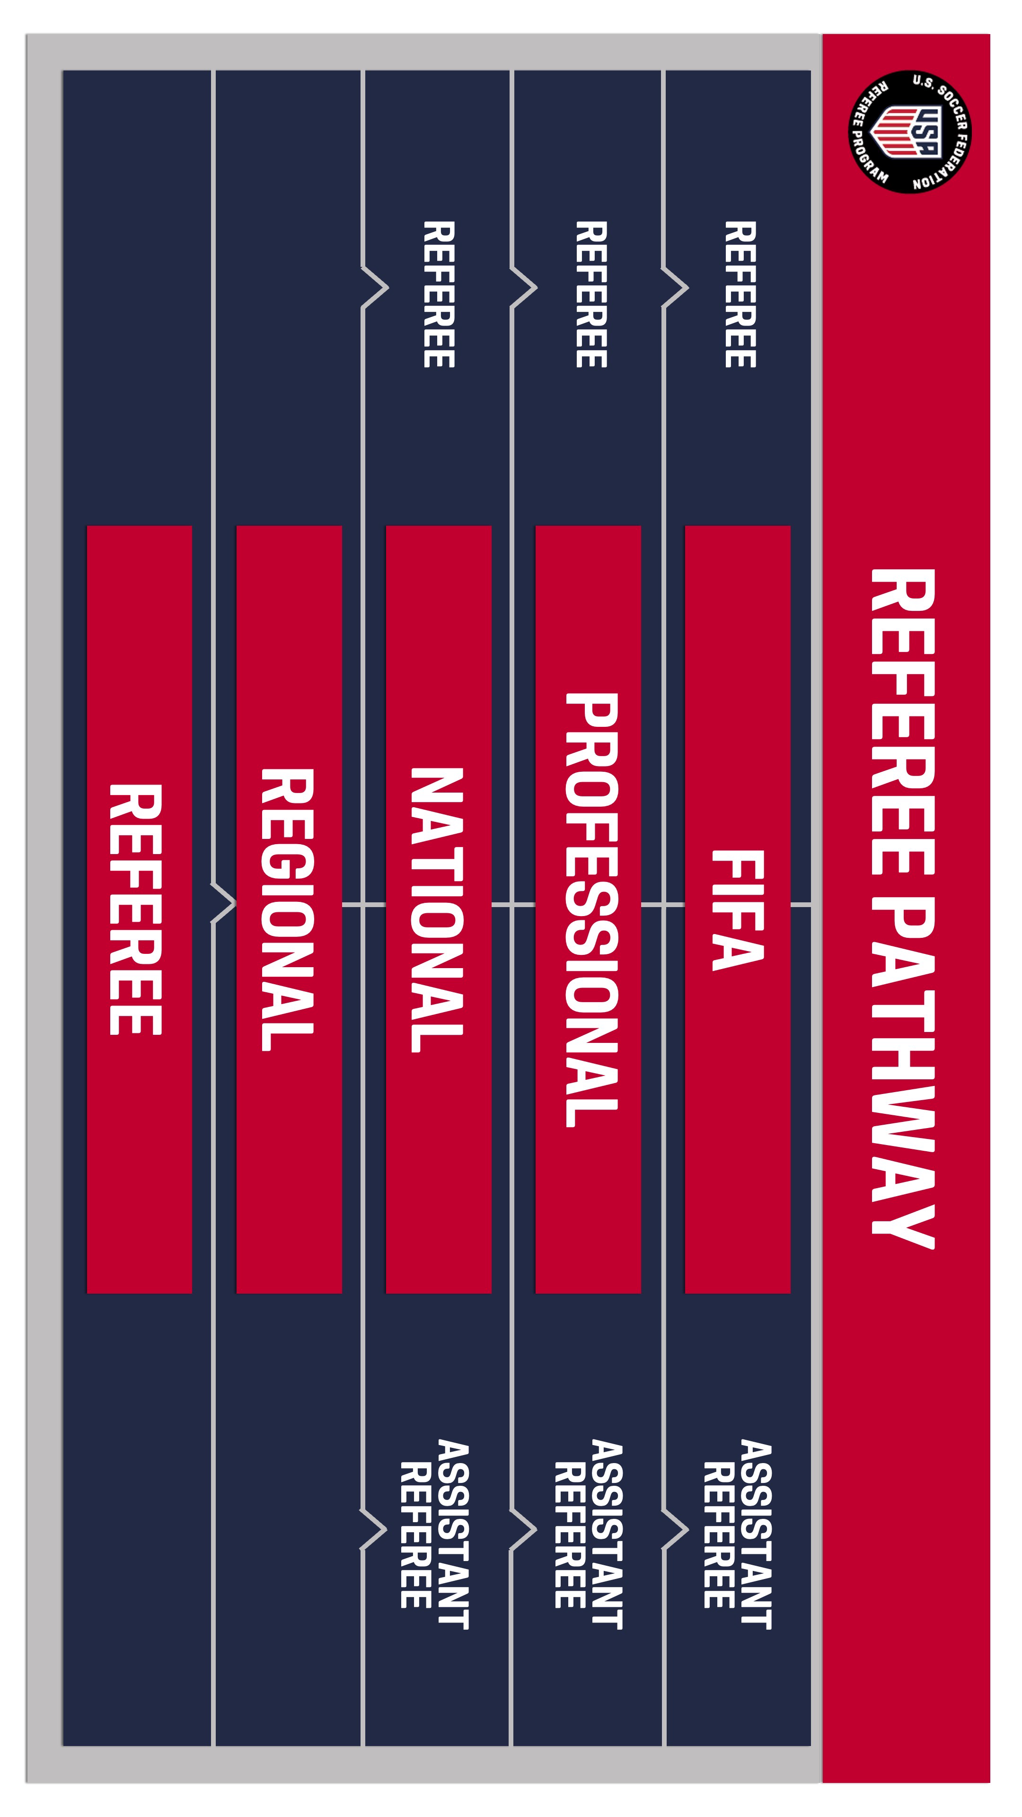
©20 22 U . S . S oc c e r | CO NF I D E NTI A L — Not to be s h ar e d w i th ou t U .S . S oc c e r appr ov a l

©20 22 U . S . S oc c e r | CO NF I D E NTI A L — Not to be s h ar e d w i th ou t U .S . S oc c e r appr ov a l
2024 REFEREE COACH PATHWAY
ELIGIBILITY & GENERAL REQUIREMENTS
16

FIRST-TIME REFEREE MENTOR 2024 LICENSE REQUIREMENTS
©20 22 U . S . S oc c e r | CO NF I D E NTI A L — Not to be s h ar e d w i th ou t U .S . S oc c e r appr ov a l

FIRST-TIME REFEREE MENTOR REQUIREMENTS
AGE | 18 YEARS OF AGE OR OLDER
ENROLLMENT | REGISTRATION
PREVIOUS CERTIFICATION EXPERIENCE | A CUMULATIVE OF TWO (2) YEARS OF ON-FIELD EXPERIENCE AS A CERTIFIED REFEREE
SAFETY & COMPLIANCE | BACKGROUND SCREENING SAFESPORT TRAINED  SAFE AND HEALTHY PLAYING ENVIRONMENTS
TRAINING  (online and/or in-person) | REFEREE MENTOR ONLINE COURSE IN-PERSON AND VIRTUAL MEETING
PRACTICAL ASSIGNMENTS | N/A

REFEREE MENTOR

REFEREE MENTOR RE-CERTIFICATION 2024 LICENSE REQUIREMENTS
©20 22 U . S . S oc c e r | CO NF I D E NTI A L — Not to be s h ar e d w i th ou t U .S . S oc c e r appr ov a l

REFEREE MENTOR RE-CERTIFICATION REQUIREMENTS
AGE | 18 YEARS OF AGE OR OLDER
ENROLLMENT | REGISTRATION
PREVIOUS CERTIFICATION EXPERIENCE | MUST HAVE HELD AT LEAST ONE (1) REFEREE MENTOR LICENSE WITHIN THE THREE (3) PREVIOUS REGISTRATION YEARS  OR  MUST HAVE HELD A REFEREE COACH LICENSE DURING THE PREVIOUS REGISTRATION YEAR
SAFETY & COMPLIANCE | BACKGROUND SCREENING SAFESPORT TRAINED  SAFE AND HEALTHY PLAYING ENVIRONMENTS
TRAINING  (online) | ONLINE REFEREE MENTOR RECERTIFICATION COURSE
PRACTICAL ASSIGNMENTS | ONE (1) LEADING A VIDEO ANALYSIS SESSION ONE (1) LEADING A PRACTICAL EXERCISE  ONE (1) OBSERVING THE PERFORMANCE OF MATCH  OFFICIALS  MUST BE COMPLETED BEFORE THE END OF THE REGISTRATION YEAR.

REFEREE MENTOR

FIRST-TIME REFEREE COACH
REFEREE MENTOR
REFEREE COACH
©20 22 U . S . S oc c e r | CO NF I D E NTI A L — Not to be s h ar e d w i th ou t U .S . S oc c e r appr ov a l
2024 LICENSE REQUIREMENTS

FIRST-TIME REFEREE COACH REQUIREMENTS
AGE | 21 YEARS OF AGE OR OLDER
ENROLLMENT | REGISTRATION
PREVIOUS CERTIFICATION EXPERIENCE | MUST HAVE HELD A REFEREE MENTOR, REGIONAL ASSESSOR, OR REGIONAL INSTRUCTOR LICENSE FOR EACH OF THE PREVIOUS TWO (2) REGISTRATION YEARS (2022 & 2023)  OR  MUST HAVE HELD AT LEAST ONE (1) FIFA, PRO, OR NATIONAL MATCH OFFICIAL LICENSE WITHIN THE CURRENT OR PREVIOUS TWO (2) REGISTRATION YEARS
SAFETY & COMPLIANCE | NCSI BACKGROUND SCREENING SAFESPORT TRAINED  SAFE AND HEALTHY PLAYING ENVIRONMENTS
TRAINING  (online and/or in-person) | ONLINE COURSE PRE-WORK REFEREE COACH COURSE IN-PERSON SESSION
PRACTICAL ASSIGNMENTS | FOUR (4) ASSIGNMENTS IN PRE-MEETING THREE (3) ASSIGNMENTS DURING IN-PERSON MEETING  ONE (1) ASSIGNMENT POST IN-PERSON MEETING  MUST BE COMPLETED BEFORE THE END OF THE REGISTRATION YEAR.

REFEREE COACH RE-CERTIFICATION 2024 LICENSE REQUIREMENTS
REFEREE MENTOR
REFEREE COACH
©20 22 U . S . S oc c e r | CO NF I D E NTI A L — Not to be s h ar e d w i th ou t U .S . S oc c e r appr ov a l

REFEREE COACH RE-CERTIFICATION REQUIREMENTS
AGE | 21 YEARS OF AGE OR OLDER
ENROLLMENT | REGISTRATION
PREVIOUS CERTIFICATION EXPERIENCE | MUST HAVE HELD AT LEAST ONE (1) REFEREE COACH LICENSE  OR  AT LEASE ONE (1) NATIONAL REFEREE COACH LICENSE IN THE PREVIOUS THREE (3) REGISTRATION YEARS
SAFETY & COMPLIANCE | BACKGROUND SCREENING SAFESPORT TRAINED  SAFE AND HEALTHY PLAYING ENVIRONMENTS
TRAINING  (online) | REFEREE COACH RE-CERTIFICATION COURSE
PRACTICAL ASSIGNMENTS | ONE (1) LEADING A VIDEO ANALYSIS SESSION ONE (1) LEADING A FIELD SESSION  FIVE (5) GAME EVALUATIONS  INCLUDING:  POST-GAME REFLECTION WITH THE REFEREE TEAM & WRITTEN FEEDBACK FOR THE REFEREE TEAM

FIRST-TIME NATIONAL REFEREE COACH 2024 LICENSE REQUIREMENTS
REFEREE MENTOR
REFEREE COACH
NATIONAL REFEREE COACH
©20 22 U . S . S oc c e r | CO NF I D E NTI A L — Not to be s h ar e d w i th ou t U .S . S oc c e r appr ov a l

FIRST-TIME NATIONAL REFEREE COACH REQUIREMENTS
AGE | 25 YEARS OF AGE OR OLDER
ENROLLMENT | APPLICATION REQUIRED SELECTED BY U.S. SOCCER
PREVIOUS CERTIFICATION EXPERIENCE | MUST HAVE HELD A REFEREE COACH LICENSE FOR EACH OF THE TWO  (2) PREVIOUS REGISTRATION YEARS
SAFETY & COMPLIANCE | NCSI BACKGROUND SCREENING SAFESPORT TRAINED  SAFE AND HEALTHY PLAYING ENVIRONMENTS
TRAINING  (online and/or in-person) | IN-PERSON AND VIRTUAL MEETINGS ONLINE ASSIGNMENTS  U.S. SOCCER NATIONAL CAMP
PRACTICAL ASSIGNMENTS | SEVEN (7) EVALUATING THE PERFORMANCE OF MATCH OFFICIALS INCLUDING:  POST-GAME REFLECTION WITH THE REFEREE TEAM & WRITTEN FEEDBACK FOR THE REFEREE TEAM  ONE (1) LEADING A VIDEO ANALYSIS SESSION ONE (1) LEADING A PRACTICAL EXERCISE  MUST BE COMPLETED BEFORE THE END OF THE REGISTRATION YEAR

NATIONAL REFEREE COACH RE-CERTIFICATION 2024 LICENSE REQUIREMENTS
REFEREE MENTOR
REFEREE COACH
NATIONAL REFEREE COACH
©20 22 U . S . S oc c e r | CO NF I D E NTI A L — Not to be s h ar e d w i th ou t U .S . S oc c e r appr ov a l

NATIONAL REFEREE COACH RE-CERTIFICATION REQUIREMENTS
AGE | 25 YEARS OF AGE OR OLDER
ENROLLMENT | SELECTED BY U.S. SOCCER
PREVIOUS CERTIFICATION EXPERIENCE | MUST HAVE HELD A NATIONAL REFEREE COACH LICENSE DURING THE PREVIOUS REGISTRATION YEAR
SAFETY & COMPLIANCE | NCSI BACKGROUND SCREENING SAFESPORT TRAINED  SAFE AND HEALTHY PLAYING ENVIRONMENTS
TRAINING  (online and/or in-person) | IN-PERSON AND VIRTUAL MEETINGS ONLINE ASSIGNMENTS  U.S. SOCCER NATIONAL CAMP
PRACTICAL ASSIGNMENTS | SEVEN (7) EVALUATIONS OF MATCH OFFICIALS INCLUDING: POST-GAME REFLECTION WITH THE REFEREE TEAM & WRITTEN FEEDBACK FOR THE REFEREE TEAM  ONE (1) LEADING A VIDEO ANALYSIS SESSION ONE (1) LEADING A PRACTICAL EXERCISE  MUST BE COMPLETED BEFORE THE END OF THE REGISTRATION YEAR

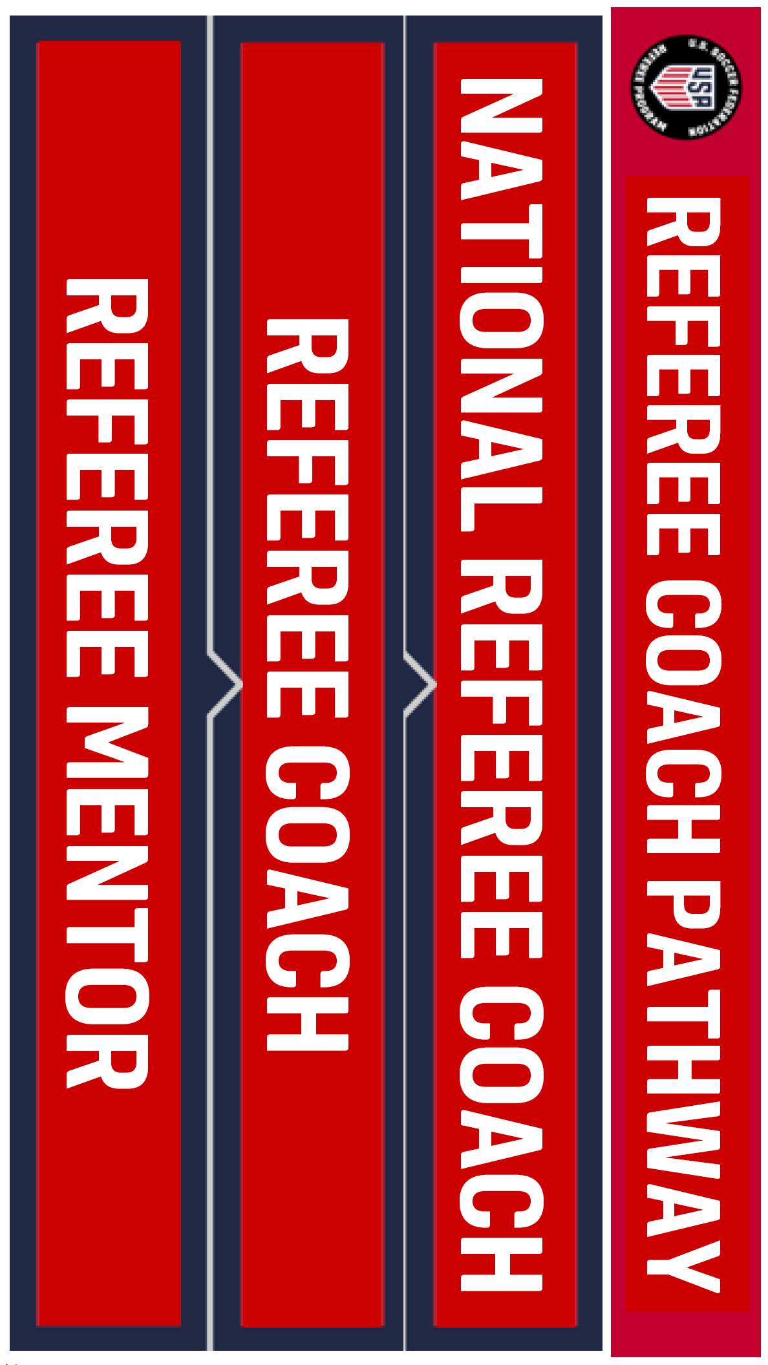
©20 22 U . S . S oc c e r | CO NF I D E NTI A L — Not to be s h ar e d w i th ou t U .S . S oc c e r appr ov a l

©20 22 U . S . S oc c e r | CO NF I D E NTI A L — Not to be s h ar e d w i th ou t U .S . S oc c e r appr ov a l
2024 ACCELERATED PATHWAYS
FOR HIGH LEVEL OFFICIALS, COACHES, AND
PLAYERS
24

ACCELERATED PATHWAY OPTIONS 2024 LICENSE REQUIREMENTS
©20 22 U . S . S oc c e r | CO NF I D E NTI A L — Not to be s h ar e d w i th ou t U .S . S oc c e r appr ov a l

2024 REGISTRATION YEAR (JULY 1, 2023 TO JUNE 30, 2024)
For the 2024 registration year, retired or current FIFAs, PRO, National Match Officials, Professional players of a certain level, or licensed U.S. Soccer Coaches of a certain level may utilize the accelerated pathway options outlined in the following slides.

LEARNING CENTER ELIGIBILITY
The Learning Center can only automatically account for the rules based on
referee licenses. For those who are current or retired players or coaches applying for these accelerated pathways, the system is unable to automatically account for your prior experience.

A request must be sent directly to the U.S. Soccer Referee Department (referee@ussoccer.org) to update course eligibility manually in these cases.

REFEREE COACH PATHWAY ACCELERATED OPTION 2024 LICENSE REQUIREMENTS
©20 22 U . S . S oc c e r | CO NF I D E NTI A L — Not to be s h ar e d w i th ou t U .S . S oc c e r appr ov a l

Who is Eligible:
RETIRED OR CURRENT FIFA, PRO, OR NATIONAL MATCH OFFICIAL LICENSE HOLDERS

For the Referee Coach Pathway 2024:
- Eligible for the First-Time Referee Coach course within two (2) registration years
of retirement (or while they currently hold a FIFA/PRO/National Match Official License)

  - Example 1: FIFA Referee retired 2022. They may take a First-Time
Referee coach course during the 2023 or 2024 registration year. OR they may start a First-Time Referee Mentor course at any time.

  - Example 2: Currently licensed FIFA Referee. They may take the First-Time Referee Coach course now or they may wait until they retire and follow Example 1 above.

Any other exceptions determined by the U.S. Soccer Referee Department on a case-by-case basis. Email: Rick Eddy, reddy@ussoccer.org for consideration.

REFEREE PATHWAY ACCELERATED OPTION 2024 LICENSE REQUIREMENTS
©20 22 U . S . S oc c e r | CO NF I D E NTI A L — Not to be s h ar e d w i th ou t U .S . S oc c e r appr ov a l

Who is Eligible:
Players and Coaches who meet the following qualifications:
- Any professional outdoor league, Division 1, 2, 3
- Coaches: C level license and higher
For the Referee Pathway:
- Eligible to start at the First-Time Referee license and advance to the First-Time Regional License one year later if all eligibility/requirements met.
  - Example: Player Retired August 2022
2022 Referee Registration Year: Player registers as First-Time Referee License (previously Grassroots Referee)
2023 Referee Registration Year: Player may upgrade to First-Time Regional License (if they meet all eligibility and license requirements)

